OS TASKS
Name: Amna
Roll Number: F2024332006
- Create a folder with the name and ID
Command mkdir amna_f2024332006
Creates a new folder named amna_f2024332006. mkdir stands for "make directory".

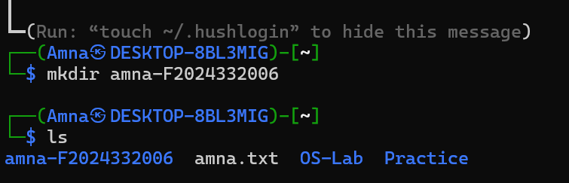
ls will show list of folders

cd amna_f2024332006
Moves us inside the folder you created. cd stands for "change directory".
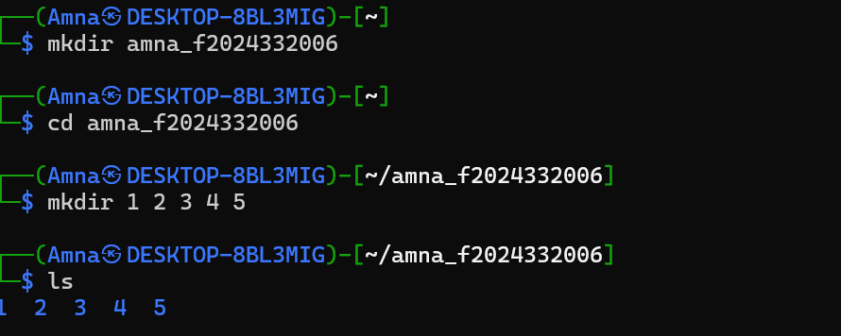

Then, for folders, we created 5 folders with mkdir, which stands for make directory

Then ls to show what we created

ls–R, which lists all files and folders, including everything inside subfolders. -R means "recursive".

Cd-3 moves to 3rd folder
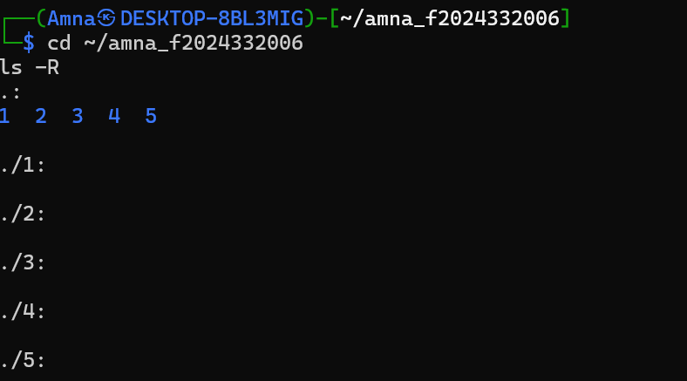

Command is nano intro.txt
Opens the nano text editor and creates a file named intro.txt. You type your intro, then save with Ctrl+S and exit with Ctrl+X.
Then for display we used command cat intro.txt It only reads the file, it does not change it.
Pwd Prints the full path of the folder you are currently in. It helps you check your location.

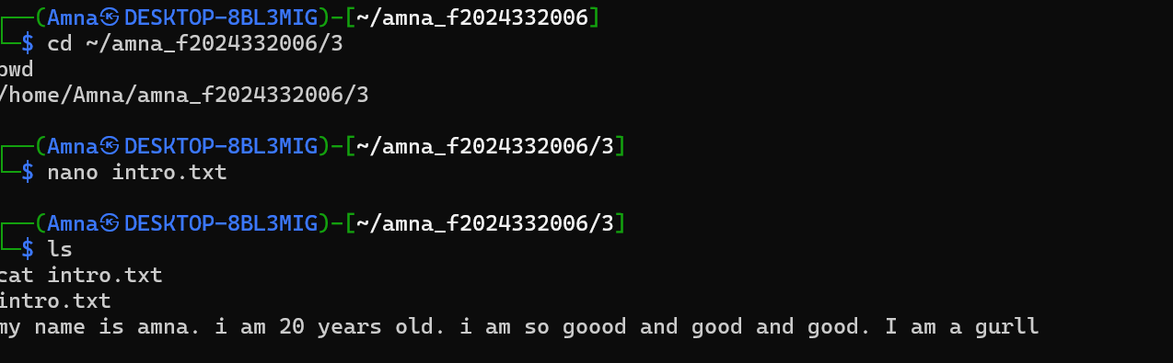

Display the console I wrote
